Hex Game – Group P

Our Goal: Solving the Hex Problem with Reinforcement Learning Techniques

## What is Hex?

Ein Bild, das Screenshot, Muster, Grafiken, Kunst enthält.

<https://en.wikipedia.org/wiki/Hex_(board_game)>

Hex is a game that is played by two players. The goal is to create a connected line from the one side to the other. The opponent that achieves that goal wins the game.  
Usually the game is played on a 11x11 rhombus board. Other board formations like 3x3, 5x5, 7x7 will be covered in this paper.

## Ideas

We brainstormed some ideas as a group. Following Algorithms were written down:

* DDPG
* DQN/Double DQN
* Actor Critic
* Advantage Actor Critic (A2C)
* A3C
* Genetic Algorithms xd

We rooted for DDPG for a long time and it was our final decision over the rest.

## First Steps

After we all understood the baseline-agents and also how the class HexPosition works. We got to work. The DDPG-Algorithm isn’t the simplest one out there. (see following figure)

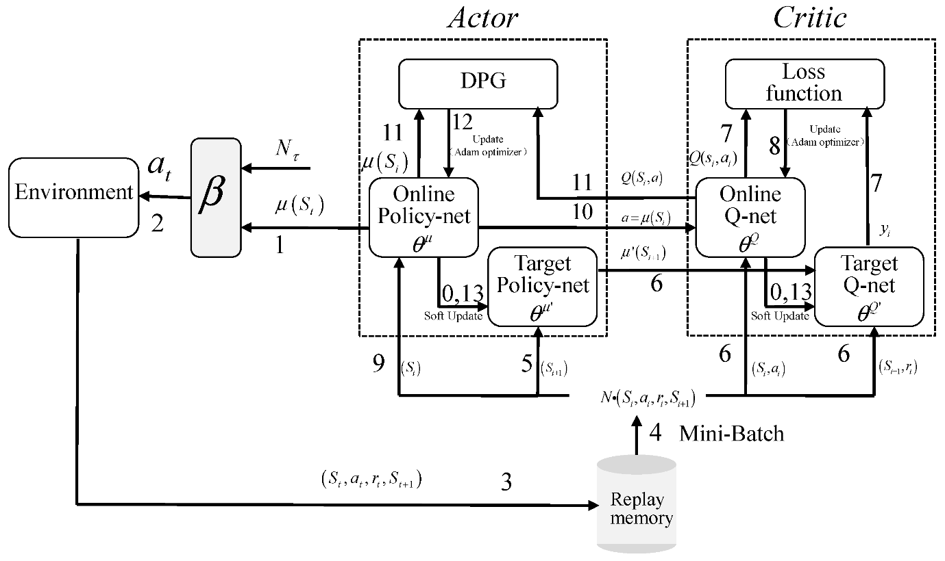

<https://www.mdpi.com/2076-3417/12/19/9703>

So, we tried to start “small” with a Double DQN with Replay Buffer. Especially it is a DDPG without the critic, and a discrete action space.

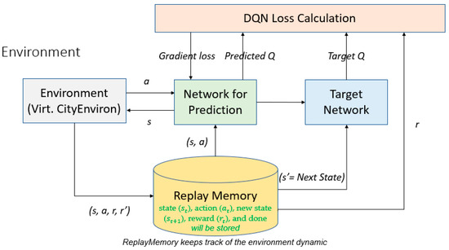

<https://www.mdpi.com/2076-3417/12/7/3220>